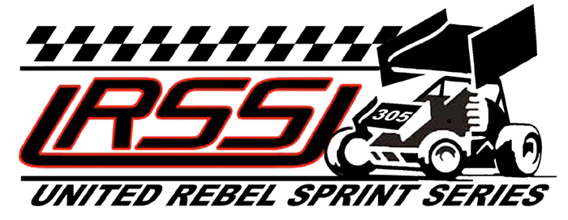

DRIVING SEMINAR PICTURE ORDER FORM

Pictures will be made available for all participants of the 2008 URSS Driving Seminar, both during their on track Sessions and Pit shots in the car.

Sizes and Prices are as follows:

4 x 6 -- $ 2
5 x 7 -- $ 5
8 x 10 -- $ 10

Also available

8 x 10 -- $ 15 – Personalized with your name and a pit side shot cut into the track shot

Proofs can be sent via e-mail at a low resolution. Prints will be made from the original resolution for the best clarity.

All photos will be mailed in appropriate packaging to prevent damage.
Flat rate S/H **** 8 x 10 orders - $5 **** 5 x 7 and 4 x 6 orders - $ 3

Shipping Information:

Name _______________________________________
Address _______________________________________
_______________________________________

E-Mail _______________________________________

Send orders and payment to:

Terry J. Pfeifer
2107 East 21st #9
Hays, Kansas 67601
785-650-4956
info@actionracingphotography.com

